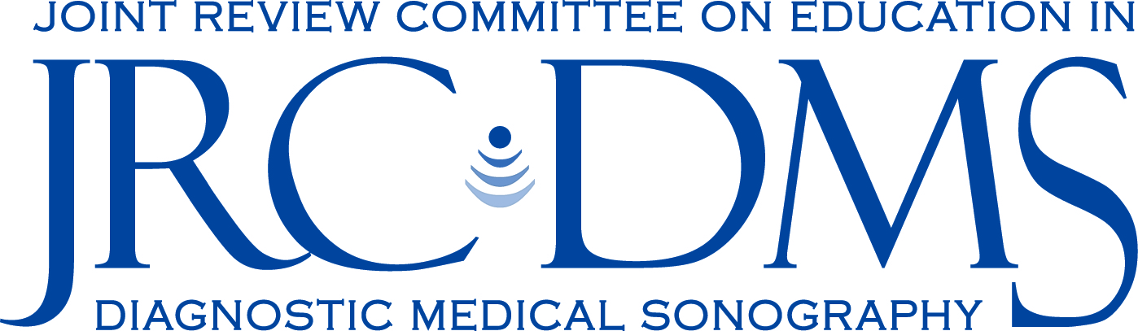

Policy: Exception to Clinical Competency

Description: In general, student clinical competencies and proficiencies as required by CAAHEP Standards are documented by evaluation of students in a clinical setting with the student being directly observed performing a sonographic exam on a patient. The JRC-DMS recognizes that some clinical services are not available or offered in communities served by sonography training programs. This policy serves to outline a process by which program may apply for an exception to document clinical competency/proficiency by other methods than live scanning on patients in a clinical setting.

Requirements

- The program must demonstrate how students will be evaluated on the hands on skill for the clinical competency.
- The program must demonstrate methods for assuring that all students receive equitable simulated clinical experience for this competency.
- The program will provide written statements from the program director, medical advisor and all clinical sites that the requested exam (competency) is not performed at any of the clinical sites affiliated with the program.

Application Procedure

- All information regarding the request will be provided on forms supplied by the JRC-DMS.
- The JRC-DMS Board of Directors will consider each request on a case by case basis.

Eligible Competencies

Programs may apply for exceptions to clinical competency requirements only for competencies listed below:

- General learning concentration:

  - Non cardiac chest (ex. r/o pleural effusion)
  - Abdominal Doppler (ex. Portal vein, liver Doppler)

- Vascular learning concentration:

  - Intracranial Cerebrovascular (transcranial Doppler)
  - Upper extremity arterial
  - Segmental pressures
  - Aorta/renal ratios

